Applied Physics Lab (LAB-105) Semester: Fall 2023
Lab No. 9 (Optoelectronic devices) Max Marks: 10
Date: Week 9

Experiment No. 9
To study Optoelectronic Devices like LED, Photo diode, LDR and opto-coupler and perform experiment on 7-segment LED display.
Equipment
Trainer Board
SC56 Seven-Segment LED Display (Common Cathode)
LED Individual.
Photodiode
Light Dependent Resistor (LDR)
Opto-Coupler
Resistor 470 Ohm (x 9)

Theory
SC56 is a Single-digit LED Numeric Display. The device is made with gallium phosphide. It has low current operation and easily mounts on PC boards or sockets.
Procedure
- Draw diagram of the opto-electronic components provided: LED, Photo diode, LDR and opto-coupler and note their function.
- Mount the Seven Segment Display on Breadboard and apply voltage from Trainer Board as shown in the diagram. Connect current limiting resistor of 470 ohm in series with each segment of the LED unit
- Obtain digit display of 1, 2, 8, A and F by applying voltages to its specified pins.

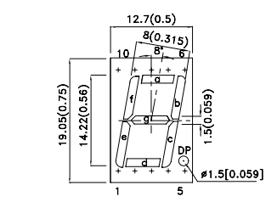
Pin locations 1 to 5 (Bottom Side) and 6 to 10 (Top side)
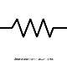
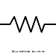
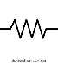





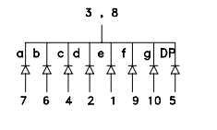
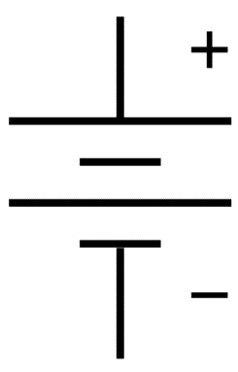

Each Resistor is 470 ohms. Its purpose is to limit the current through the LED diode. Pins No. of the LED are indicated. 1 to 5 (bottom side) and 6 to 10 (Top side). Pin 3 and 8 are GND (0 volt)
The Voltage obtained from Trainer Board is 5V. The LED is Common Cathode type which means that cathode of all LEDs are connected to GND (0 Volts)

